**INTRODUCTION:**

**A database management system is a system software which system is crucial for any institute. Our project was to create a database management system for a beautiparlour. In order to do this we had gone through this phase**

**-Scenario**

**-ER diagram**

**-normalization**

**-Table Creation**

**-Data Insertion**

**-Query Writing**

**Scenario**:

Our project was to create a database management system for a beauty parlour. In order to create a database management system for a beauty parlour we have visited ‘Persona’.

In this beauty parlour, they have to store the address, email, and owner id of owner. Owner has a beauty parlour and beauty parlour have branches. They keep beauty parlour name, branch id, branch name and branch address in the database. Branches have to keep appointments with customer and an appointment has time, id, and date. Appointments are booked by customer and customer has name, address, phone number, gender, and id. An appointment has services and services have name, id, price, time. On the other hand, services are done by beauticians and beauticians have name, id, arrival time, salary, gender, phone number, skills.

A branch has a manager and manager has name, number, salary, email, hiredate, id and address. A branch has a beauty shop and they sell beauty products which has name, price id, stock, selling date. A beauty shop has shop keeper and shop keeper has name, id, hiredate, email, number, salary.Thats all data persona store in their database management system.

Owner --------1-------have----------1-------Beauty_parlour

UNF:

Have(O_ID, O_email, O_adress , BP_name, BP_license_no.)

1NF:

There is no multiple attribute.

1 .O_ID ,O_name, O_email, place_name, road.no. , BP_name, BP_license_no.

2NF:

1 .O_ID ,O_name, O_email, place_name, road.no.

2 .BP_name, BP_license_no.

3NF:

1.O_ID , O_name, O_email.

2.Place_name, road.no.

3.BP_name, BP_license_no.

TABLE CREATION:

1.O_ID , O_name, O_email, **A_code** ;

2.A_code ,Place_name, road.no.

3.BP_name, BP_license_no.

Beauty_parlour --------1-------has----------*-------Branches

UNF:

Has ( BP_name, BP_license_no., Branch_id, branch_name, place_name, road.no.)

1NF:

There is no multiple attribute.

1. BP_name, BP_license_no. , Branch_id, branch_name, place_name, road.no.

2NF:

1. BP_name, BP_license_no.
2. Branch_id, branch_name, place_name, road.no.

3NF:

1. BP_name, BP_license_no.
2. Branch_id, branch_name
3. place_name, road.no.

TABLE CREATION:

1. BP_name, BP_license_no.
2. Branch_id, branch_name ,**A_code**,**BP_license_no.**
3. A_code ,place_name, road.no.

Branches --------1-------have----------1-------Manager

UNF:

Have (Branch_id , Branch name, place_name, road.no. , M_hiredate, M_email, M_id, place_name, road.no. , M_name, M_salary, M_number)

1NF:

There is no multiple attribute .

1. Branch_id , Branch name, place_name, road.no. , M_hiredate, M_email, M_id, place_name, road.no. , M_name, M_salary, M_number .

2NF:

1. Branch_id , Branch name, place_name, road.no.
2. M_hiredate, M_email, M_id, place_name, road.no. , M_name, M_salary, M_number .

3NF:

1. Branch_id , Branch name
2. place_name, road.no.
3. M_hiredate, M_email, M_id, ,M_name, M_salary, M_number.

TABLE CREATION:

1. Branch_id , Branch name, **A_code**
2. A_code, place_name, road.no.
3. M_hiredate, M_email, M_id, , M_name, M_salary, M_number , **A_code**,**Branch_id**

Branches --------1-------has----------*-------Employee

UNF:

Has (Branch_id , Branch name, place_name, road.no. , E_id, E_name, E_arr_time , E_working_hour , E_number , E_gender , E_salary)

1NF:

There is no multiple attribute .

1. Branch_id ,Branch_name, place_name, road.no. , E_id, E_name, E_arr_time ,E_working_hour , E_number , E_gender , E_salary .

2NF:

1. Branch_id ,Branch_name, place_name, road.no.
2. E_id, E_name, E_arr_time ,E_working_hour , E_number , E_gender , E_salary .

3NF:

1. Branch_id ,Branch_name.
2. Place_name, road.no.
3. E_id, E_name, E_arr_time ,E_working_hour , E_number , E_gender , E_salary .

TABLE CREATION:

1. Branch_id ,Branch_name, **A_code**.
2. A_code ,Place_name, road.no.
3. E_id, E_name, E_arr_time ,E_working_hour , E_number , E_gender , E_salary, **Branch_id** .

Branches --------1-------have----------*-------Appointment

UNF:

Have (Branch_id , Branch name, place_name, road.no. , A_time , A_id, A_date )

1NF:

There is no multiple attribute .

1. Branch_id , Branch name, place_name, road.no., A_time , A_id, A_date

2NF:

1. Branch_id , Branch name, place_name, road.no.
2. A_time ,A_id, A_date.

3NF:

1. Branch_id , Branch name
2. place_name, road.no.
3. A_time ,A_id, A_date.

TABLE CREATION :

1. Branch_id , Branch name , **A_code**
2. A_code,place_name, road.no.
3. A_time ,A_id, A_date , **Branch_id .**

Appointment -------*-----Booked by-------*------Customer

UNF:

Booked by (A_time ,A_id, A_date , C_id, C_name , C_gender, place_name, road.no. , C_phone, C_email )

1NF:

There is no multiple attribute.

1. A_time ,A_id, A_date , C_id, C_name , C_gender, place_name, road.no. , C_phone, C_email .

2NF:

1. A_time , A_id, A_date
2. C_id,C_name , C_gender, place_name, road.no. , C_phone, C_email .

3NF:

1. A_time , A_id, A_date
2. C_id,C_name , C_gender , C_phone, C_email .
3. A_code, place_name, road.no.

TABLE CREATION:

1. A_time , A_id, A_date
2. C_id,C_name , C_gender , C_phone, C_email, **A_code**.
3. A_code, place_name, road.no.
4. **A_id** , **C_id**

Appointment ---------*-------By--------*--------Services

UNF:

By (A_time ,A_id, A_date , S_name, S_id, S_price , S_time)

1NF:

There is no multiple attribute.

1. A_time ,A_id, A_date , S_name, S_id, S_price , S_time.

2NF:

1. A_time , A_id, A_date
2. S_name, S_id, S_price , S_time

3NF:

1. A_time , A_id, A_date
2. S_name, S_id, S_price , S_time

TABLE CREATION :

1. A_time , A_id, A_date
2. S_name, S_id, S_price , S_time
3. **A_id**, **S_id**

Services ---------*-------provide--------1--------Beauticians

UNF:

Provide (S_name, S_id, S_price , S_time , B_gender , B_id, B_name , B_phone, place_name, road.no., B_salary, skill, B_arr_time )

1NF:

Skill is the multiple attribute .

1. S_name, S_id, S_price , S_time , B_gender , B_id, B_name , B_phone, place_name, road.no., B_salary, skill, B_arr_time

2NF:

1. S_name, S_id, S_price , S_time
2. B_gender , B_id, B_name , B_phone, place_name, road.no., B_salary, skill, B_arr_time

3NF:

1. S_name, S_id, S_price , S_time
2. B_gender , B_id, B_name, , B_phone, ., B_salary, skill, B_arr_time
3. A_code, place_name, road.no

TABLE CREATION :

1. S_name, S_id, S_price ,S_time, **B_id , skill.**
2. B_gender , B_id, B_name, , B_phone, ., B_salary, skill, B_arr_time, **A_code**
3. A_code,place_name, road.no.

Manager ---------1-------under--------*--------Beauticians

UNF:

Under ( M_hiredate, M_email, M_id, place_name, road.no. , M_name, M_salary, M_number, , B_gender , B_id, B_name , B_phone, place_name, road.no., B_salary, skill, B_arr_time )

1NF:

Skill is the multiple attribute.

1. M_hiredate, M_email, M_id, place_name, road.no. , M_name, M_salary, M_number, B_gender , B_id, B_name , B_phone, place_name, road.no., B_salary, skill, B_arr_time.

2NF:

1. M_hiredate, M_email, M_id, place_name, road.no. , M_name, M_salary, M_number.
2. B_gender ,B_id, B_name , B_phone, place_name, road.no., B_salary, skill, B_arr_time.

3NF:

1. M_hiredate, M_email, M_id ,M_name, M_salary, M_number.
2. place_name, road.no.
3. B_gender ,B_id, B_name , B_phone, B_salary, skill, B_arr_time.

TABLE CREATION :

1. M_hiredate, M_email, M_id ,M_name, M_salary, M_number, **A_code**.
2. A_code,place_name, road.no.
3. B_gender ,B_id, B_name , B_phone, B_salary, skill, B_arr_time, **A_code**, **M_id**.

Branches ---------1-------has--------1--------Beautishop

UNF:

Has(Branch_id , Branch_name, place_name, road.no., P_name, shop_id,P_id,P_stock, P_price, P_selling_date)

1NF:

There is no multiple attribute.

1. Branch_id , Branch_name, place_name, road.no., P_name, shop_id,P_id,P_stock, P_price, P_selling_date

2NF:

1. Branch_id ,Branch_name, place_name, road.no.
2. P_name, shop_id,P_id,P_stock, P_price, P_selling_date

3NF:

1. Branch_id , Branch_name
2. place_name, road.no.
3. P_name, Shop_id,P_id,P_stock, P_price, P_selling_date

TABLE CREATION:

1. Branch_id ,Branch_name, **A_code, P_id, Shop_id.**
2. A_code ,place_name, road.no.
3. P_name, Shop_id,P_id, P_stock, P_price, P_selling_date

Beautishop ---------1-------has--------1--------Shopkeeper

UNF:

Has (P_name, shop_id,P_id,P_stock, P_price, P_selling_date, S_id,S_name, S_hiredate, S_salary, S_number, S_email )

1NF:

There is no multiple attribute .

1. P_name, Shop_id,P_id,P_stock, P_price, P_selling_date, S_id, S_name, S_hiredate, S_salary, S_number, S_email, place_name, road.no.

2NF:

1. P_name, P_id, P_stock, P_price, P_selling_date
2. S_id, S_name, S_hiredate, S_salary, S_number, S_email, place_name, road.no.

3NF:

1. P_name, Shop_id,P_id,P_stock, P_price, P_selling_date
2. S_id, S_name, S_hiredate, S_salary, S_number, S_email
3. place_name, road.no.

TABLE CREATION :

1. P_name, shop_id,P_id,P_stock, P_price, P_selling_date
2. S_id, S_name, S_hiredate, S_salary, S_number, S_email, **A_code, shop_id,P_id.**
3. A_code, place_name, road.no.

TABLE COLLECTIONS:

1.O_ID , O_email, **A_code** .

2.A_code , Place_name, road.no.

3.BP_name, BP_license_no.

~~4. BP_name, BP_license_no.~~

5. Branch_id, branch_name ,**A_code** , **BP_license_no**.

~~6. A_code ,place_name, road.no.~~

~~7. Branch_id , Branch name~~**~~, A_code~~**~~.~~

~~8. A_code, place_name, road.no.~~

9. M_hiredate, M_email, M_id ,M_name, M_salary, M_number**, A_code ,Branch_id**.

~~10. Branch_id ,Branch_name,~~ **~~A_code~~**~~.~~

~~11. A_code ,Place_name, road.no.~~

12. E_id, E_name, E_arr_time ,E_working_hour , E_number , E_gender , E_salary, **Branch_id** .

~~13. Branch_id , Branch name ,~~ **~~A_code~~**

~~14. A_code ,place_name, road.no.~~

15. A_time ,A_id , A_date , **Branch_id** .

~~16. A_time,A_id , A_date~~

17. C_id ,C_name , C_gender , C_phone, C_email , **A_code**.

~~18. A_code, place_name, road.no.~~

19. **A_id** ,**C_id**

~~20. A_time ,A_id , A_date~~

~~21. S_name, S_id, S_price ,S_time~~

22. **A_id** ,**S_id**

23. S_name, S_id, S_price ,S_time, **B_id** , **skill**.

~~24. B_gender,B_id, B_name, B_phone, B_salary, skill,~~ **~~A_code~~**

~~25. A_code ,place_name, road.no.~~

~~26. M_hiredate, M_email, M_id ,M_name, M_salary, M_number~~**~~, A_code~~**~~.~~

~~27. A_code ,place_name, road.no.~~

28. B_gender,B_id, B_name , B_phone, B_salary, skill, A_code, **M_id.**

~~29. Branch_id ,Branch_name,~~ **~~A_code~~**~~,~~ **~~P_id, Shop_id.~~**

~~30. A_code ,place_name, road.no.~~

31. P_name, Shop_id ,P_id, P_stock, P_price, P_selling_date

~~32. P_name, shop_id, P_id, P_stock, P_price, P_selling_date~~

33. Sk_id, Sk_name, Sk_hiredate, Sk_salary, Sk_number, Sk_email, **A_code, shop_id,P_id.**

~~34. A_code, place_name, road.no.~~

FINAL TABLE:------------- #TABLE_NAME

1. O_id,O_name, **A_code**---**#Owner**

2. A_code, place name, road.no. ----**# Address**

3.BP_name, BP_licience no ------**#Beautiparlour**

4.Branch_id, branch_name, **A_code, BP_licience**------**#Branch**

5. M_hire date, M_email, M_id, M-name, M_salary, M_number,**A_code,Branch_id------#Manager**

6. E_id,E_name, E_arr-time, E_ working-hour, E_number, E_gender, E_salary ---------**#Employee**

7. A_time, A_id, A_id, **A_date, branch_id ------#Appointment**

8. C_id, C_name, C_gender, C_phone, C_email**, A_code-----#Customer**

9. **A_id, C_id ----------#f1_k_many**

10**. A_id,S_id**, -----------**#f2_k_many**

11. S_name, S_id ,S_price , S_time, **B_id , Skill**---------**#Service**

12. B_gender, B_id, B_name, B_phone, B_salary, Skill**, A_code, Mid -----------------------#Beautician**

13. P_name, shop_id, P_id ,P_stock, P_price , P_selling date, **Branch_id------------------#Shop**

14. S_name, S_id, S_hiredate, S_salary, S_number, S_email**, Acode, shop_id ,P_id** ----------**#Shop-Keeper**

TABLE CREATION:-

**1.create table Address (A_code number(10) primary key, Place_name varchar2(15), Road_no number(10));**

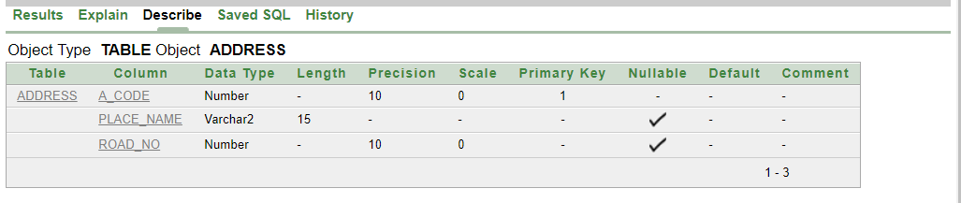

**2.create table Owner (O_id number(10) primary key, O_email varchar2(30), A_code number(10));**

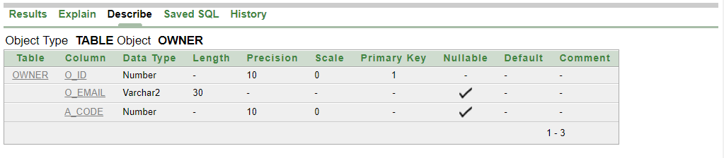

**3. create table Beautiparlour (BP_name varchar2(20), BP_licience number(10));**

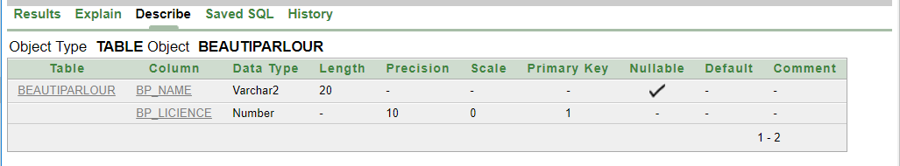

**4.create table Branch (Branch_id number(10) primary key, Branch_name varchar2(30), A_code number(10), BP_licience number(10));**

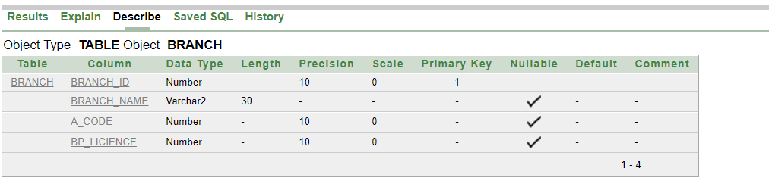

**5.create table Manager (M_hiredate varchar2(10), M_email varchar2(30), M_id number(10) primary key,M_name varchar2(30), M_salary number(10), M_number number(15), A_code number(10), Branch_id number(10));**

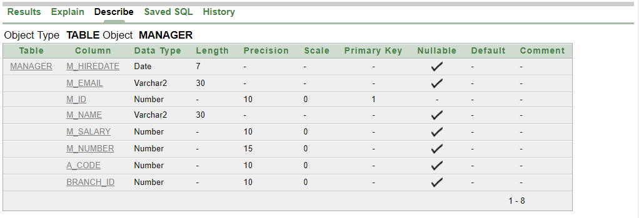

**6.create table Employee (E_id number(10) primary key, E_name varchar2(30),E_arr_time varchar2(10), E_working_hour number(10),E_number number(15), E_gender varchar2(10), E_salary number(10), Branch_id number(10));**

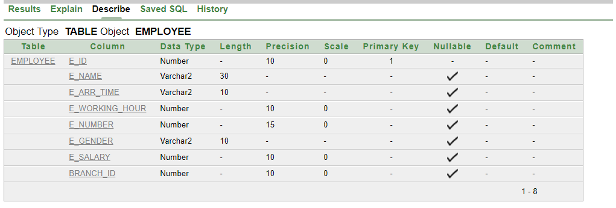

**7.create table Appointment (A_time varchar2(15), A_id number(10) primary key, A_date varchar2(10), Branch_id number(10));**

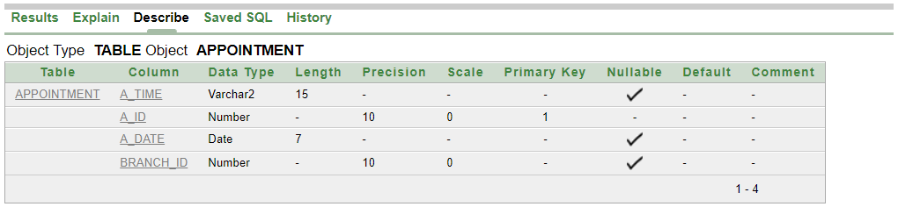

**8.create table Customer (C_id number(10) primary key, C_name varchar2(30), C_gender varchar2(10), C_phone number(15), C_email varchar2(30), A_code number(10));**

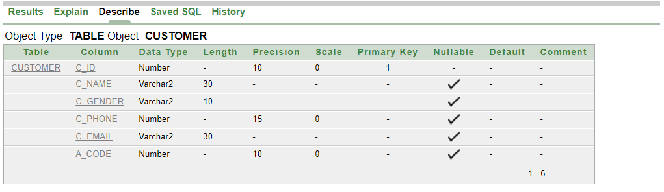

**9.create table f1_k_many (A_id number(10), C_id number(10));**

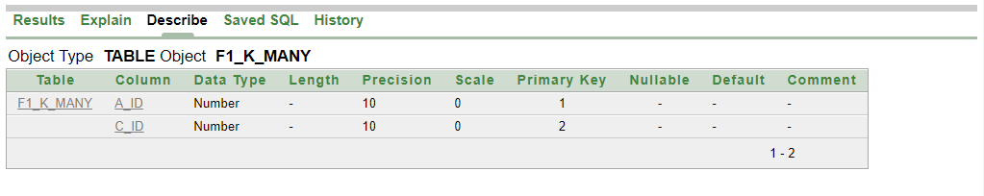**10.create table f2_k_many (A_id number(10), S_id number(10));**

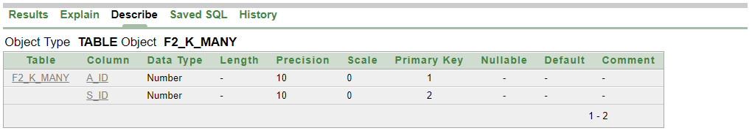

**11. create table Service (S_name varchar2(30), S_id number(10) primary key, S_price number(10), S_time varchar2(10), B_id number(10), skill varchar2(30));**

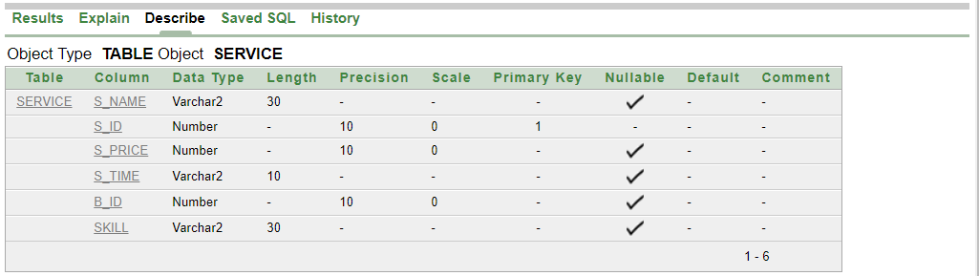

**12.create table Beautician (B_id number(10), B_name varchar2(30), B_gender varchar2(10), B_phone number(15), B_salary number(10),skill varchar2(30), A_code number(10), M_id number(10));**

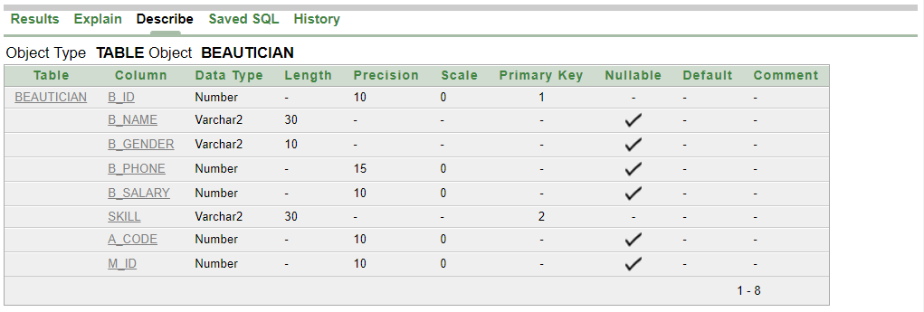

**13. create table Shop ( P_name varchar2(30), Shop_id number(10), P_id number(10), P_stock varchar2(10), P_price number(10), P_selling_date varchar2(15), Branch_id number(10));**

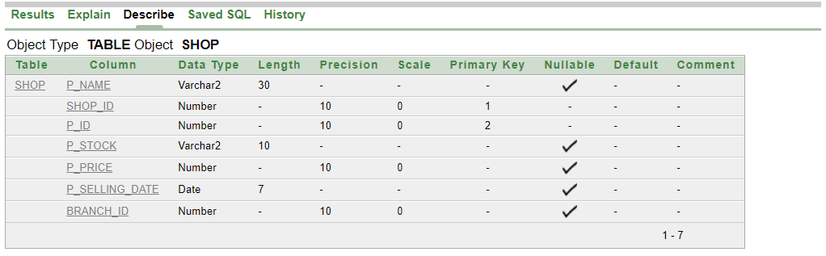

**14. create table Manager (SK_hiredate varchar2(10),SK_name varchar2(30), SK_email varchar2(30), SK_id number(10) primary key, SK_salary number(10), SK_number number(15), A_code number(10), Shop_id number(10), P_id number(10));**

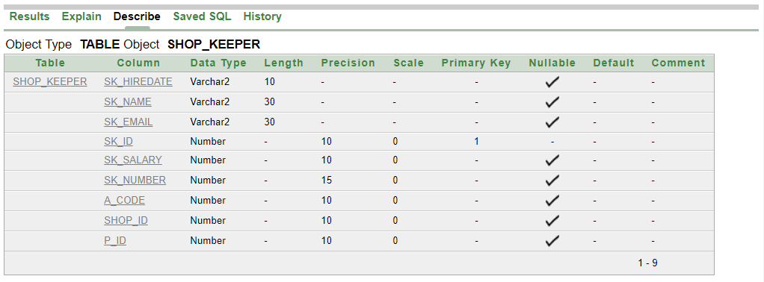

**Foreign & Primary keys set-up:**

alter table Owner add constraint ab foreign key (A_code) references Address (A_code);

alter table Branch add constraint ac foreign key (A_code) references Address (A_code);

alter table Manager add constraint ad foreign key (A_code) references Address (A_code);

alter table Customer add constraint ae foreign key (A_code) references Address (A_code);

alter table Beautician add constraint af foreign key (A_code) references Address (A_code);

alter table shop_keeper add constraint ag foreign key (A_code) references Address (A_code);

alter table Branch add constraint ah foreign key (BP_licience) references Beautiparlour (BP_licience);

alter table Manager add constraint ai foreign key (Branch_id) references Branch (Branch_id);

alter table Employee add constraint aj foreign key (Branch_id) references Branch (Branch_id);

alter table Appointment add constraint ak foreign key (Branch_id) references Branch (Branch_id);

alter table Shop add constraint al foreign key (Branch_id) references Branch (Branch_id);

alter table Beautician add constraint am primary key (B_id, skill);

alter table f1_k_many add constraint an primary key (A_id, C_id);

alter table f2_k_many add constraint ao primary key (A_id, S_id);

alter table Shop add constraint ap primary key (Shop_id, P_id);

alter table service add constraint aq foreign key (B_id, skill) references Beautician (B_id, skill);

alter table Shop_keeper add constraint ar foreign key (Shop_id, P_id) references Shop (Shop_id, p_id);

alter table Beautician add constraint au foreign key (M_id) references Manager (M_id);

alter table f1_k_many add constraint av foreign key (A_id) references Appointment (A_id);

alter table f1_k_many add constraint aw foreign key (C_id) references customer (C_id);

alter table f2_k_many add constraint ax foreign key (A_id) references Appointment (A_id);

alter table f2_k_many add constraint ay foreign key (S_id) references service (S_id);

TABLE INSERTION:

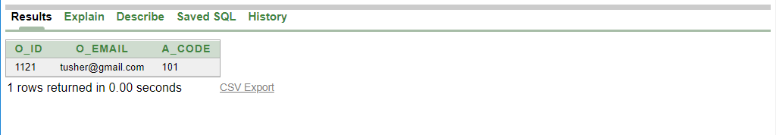

**1.Owner:-**

INSERT INTO owner VALUES (1121,'tusher@gmail.com',101);

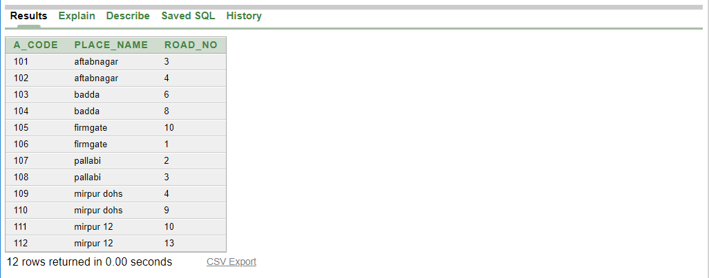

**2.Address:-**

INSERT INTO address VALUES

(101,'aftabnagar',3);

INSERT INTO address VALUES

(102,'aftabnagar',4);

INSERT INTO address VALUES

(103,'badda',6);

INSERT INTO address VALUES

(104,'badda',8);

INSERT INTO address VALUES

(105,'firmgate',10);

INSERT INTO address VALUES

(106,'firmgate',1);

INSERT INTO address VALUES

(107,'pallabi',2);

INSERT INTO address VALUES

(108,'pallabi',3);

INSERT INTO address VALUES

(109,'mirpur dohs',4);

INSERT INTO address VALUES

(110,'mirpur dohs',9);

INSERT INTO address VALUES

(111,'mirpur 12',10);

INSERT INTO address VALUES

(112,'mirpur 12',13);

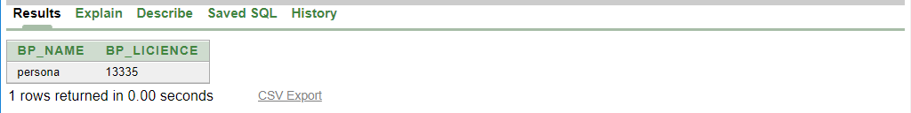

**3.Beutiparlour:-**

INSERT INTO beautiparlour VALUES ('persona',13335);

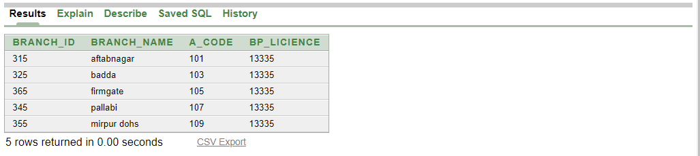

**4.Branch:-**

INSERT INTO branch VALUES (315,'aftabnagar',101,13335);

INSERT INTO branch VALUES (325,'badda',103,13335);

INSERT INTO branch VALUES (365,'firmgate',105,13335);

INSERT INTO branch VALUES (345,'pallabi',107,13335);

INSERT INTO branch VALUES (355,'mirpur dohs',109,13335);

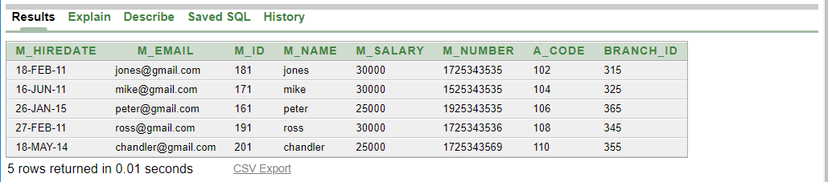

**5.Manager:-**

INSERT INTO manager VALUES (to_date('18-2-2011','dd-mm-yyyy'),'jones@gmail.com',181,'jones',30000,01725343535,102,315);

INSERT INTO manager VALUES (to_date('16-6-2011','dd-mm-yyyy'),'mike@gmail.com',171,'mike',30000,01525343535,104,325);

INSERT INTO manager VALUES (to_date('26-01-2015','dd-mm-yyyy'),'peter@gmail.com',161,'peter',25000,01925343535,106,365);

INSERT INTO manager VALUES (to_date('27-2-2011','dd-mm-yyyy'),'ross@gmail.com',191,'ross',30000,01725343536,108,345);

INSERT INTO manager VALUES (to_date('18-5-2014','dd-mm-yyyy'),'chandler@gmail.com',201,'chandler',25000,01725343569,110,355);

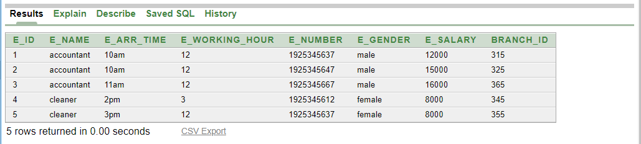

**6.Employee:-**

INSERT INTO employee values (01,'accountant','10am',12,01925345637,'male',12000,315);

INSERT INTO employee values (02,'accountant','10am',12,01925345647,'male',15000,325);

INSERT INTO employee values (03,'accountant','11am',12,01925345667,'male',16000,365);

INSERT INTO employee values (04,'cleaner','2pm',3,01925345612,'female',8000,345);

INSERT INTO employee values (05,'cleaner','3pm',12,01925345637,'female',8000,355);

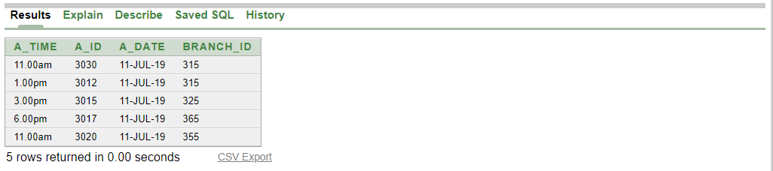

**7.Appointment:-**

INSERT INTO appointment VALUES ('11.00am',3030,to_date('11-7-2019','dd-mm-yyyy'),315);

INSERT INTO appointment VALUES ('1.00pm',3012,to_date('11-7-2019','dd-mm-yyyy'),315);

INSERT INTO appointment VALUES ('3.00pm',3015,to_date('11-7-2019','dd-mm-yyyy'),325);

INSERT INTO appointment VALUES ('6.00pm',3017,to_date('11-7-2019','dd-mm-yyyy'),365);

INSERT INTO appointment VALUES ('11.00am',3020,to_date('11-7-2019','dd-mm-yyyy'),355);

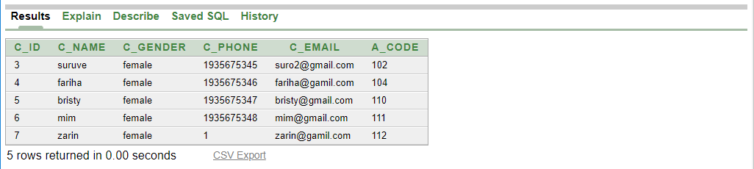

**8.Customer:-**

INSERT INTO Customer VALUES (03,'suruve','female',01935675345,'suro2@gmail.com',102);

INSERT INTO Customer VALUES (04,'fariha','female',01935675346,'fariha@gamil.com',104);

INSERT INTO Customer VALUES (05,'bristy','female',01935675347,'bristy@gmail.com',110);

INSERT INTO Customer VALUES (06,'mim','female',01935675348,'mim@gmail.com',111);

INSERT INTO Customer VALUES (07,'zarin','female',01,'zarin@gamil.com',112);

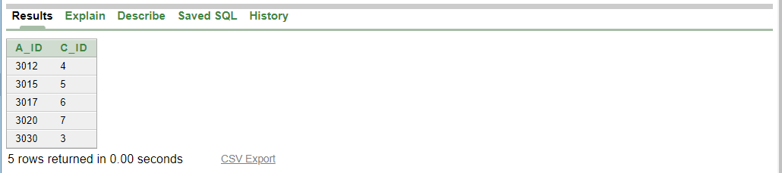

**9.f1_k_many:-**

INSERT INTO f1_k_many VALUES (3030,03);

INSERT INTO f1_k_many VALUES (3012,04);

INSERT INTO f1_k_many VALUES (3015,05);

INSERT INTO f1_k_many VALUES (3017,06);

INSERT INTO f1_k_many VALUES (3020,07);

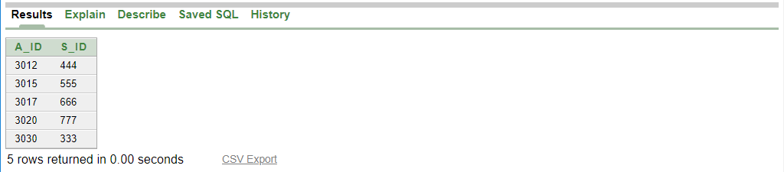

**10.f2_k_many:-**

INSERT INTO f2_k_many VALUES (3030,333);

INSERT INTO f2_k_many VALUES (3012,444);

INSERT INTO f2_k_many VALUES (3015,555);

INSERT INTO f2_k_many VALUES (3017,666);

INSERT INTO f2_k_many VALUES (3020,777);

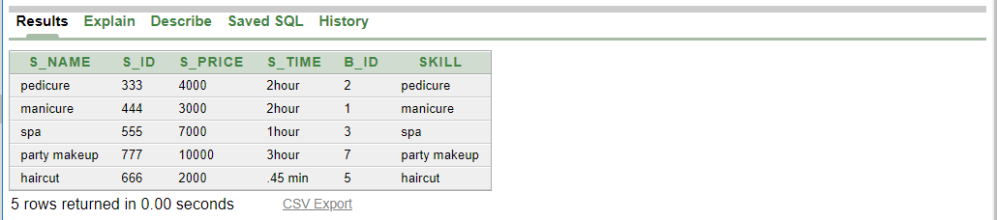

**11.Service:-**

INSERT INTO service VALUES (‘pedicure’,333,4000,’2hour’,2,’pedicure’);

INSERT INTO service VALUES (‘manicure’,444,3000,’2hour’,1,’manicure’);

INSERT INTO service VALUES (‘spa’,555,7000,’1hour’,3,’spa’);

INSERT INTO service VALUES (‘party makeup’,777,10000,’3hour’,7,’party makeup’);

INSERT INTO service VALUES (‘haircut’,666,2000,’45 min’,5,’haircut’);

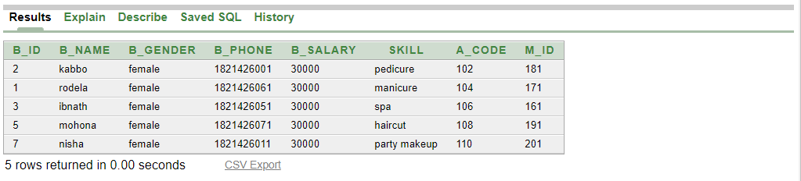

**12.Beautician:-**

INSERT INTO beautician VALUES (02,'kabbo','female',01821426001,30000,'pedicure',102,181);

INSERT INTO beautician VALUES (01,'rodela','female',01821426061,30000,'manicure',104,171);

INSERT INTO beautician VALUES (03,'ibnath','female',01821426051,30000,'spa',106,161);

INSERT INTO beautician VALUES (05,'mohona','female',01821426071,30000,'haircut',108,191);

INSERT INTO beautician VALUES (07,'nisha','female',01821426011,30000,'party makeup',110,201);

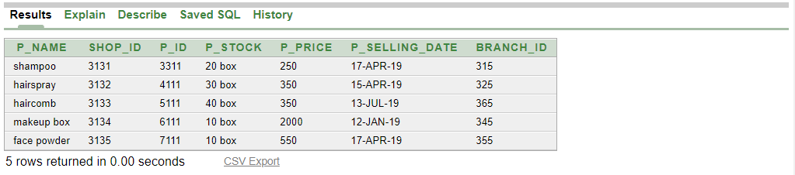

**13. Shop:-**

INSERT INTO shop VALUES (‘shampoo’,3131,3311,’250box’, 250,’ to_date('17-04-2019','dd-mm-yyyy')’,315);

INSERT INTO shop VALUES (‘hairspray’,3132,4111,’250box’, 250,’ to_date('17-04-2019','dd-mm-yyyy')’,325);

INSERT INTO shop VALUES (‘haircomb’,3133,5111,’250box’, 350,’ to_date('17-04-2019','dd-mm-yyyy')’,365);

INSERT INTO shop VALUES (‘makeup box’,3134,6111,’250box’, 2000,’ to_date('17-04-2019','dd-mm-yyyy')’,345);

INSERT INTO shop VALUES (‘face powder’ ,3135,7111,’250box’, 550,’ to_date('17-04-2019','dd-mm-yyyy')’,355);

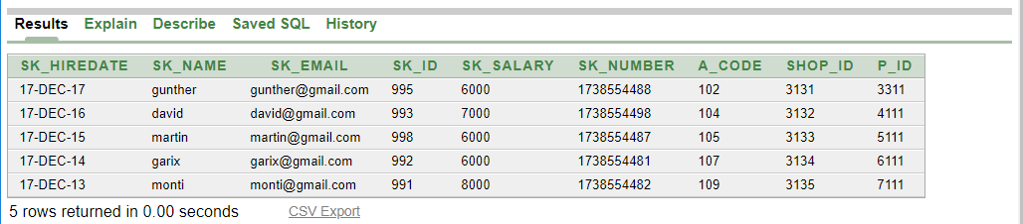

**14. Shop_keeper:-**

INSERT INTO shop_keeper VALUES (to_date('17-12-2017','dd-mm-yyyy'),'gunther','gunther@gmail.com',995,6000,01738554488,102,3131,3311);

INSERT INTO shop_keeper VALUES (to_date('17-12-2016','dd-mm-yyyy'),'david','david@gmail.com',993,7000,01738554498,104,3132,4111);

INSERT INTO shop_keeper VALUES (to_date('17-12-2015','dd-mm-yyyy'),'martin','martin@gmail.com',998,6000,01738554487,105,3133,5111);

INSERT INTO shop_keeper VALUES (to_date('17-12-2014','dd-mm-yyyy'),'garix','garix@gmail.com',992,6000,01738554481,107,3134,6111);

INSERT INTO shop_keeper VALUES (to_date('17-12-2013','dd-mm-yyyy'),'monti','monti@gmail.com',991,8000,01738554482,109,3135,7111);

**QUERY WRITING:**

**Single row function :**

1. **Find the details of the customer whose name is Suruve.**

**Ans: SELECT * FROM CUSTOMER WHERE LOWER (C_NAME)='suruve';**

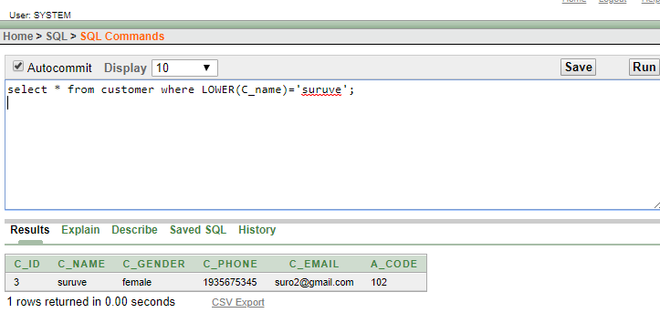

1. **Display the place names in upper case .**

**Ans: select UPPER(PLACE_NAME) FROM ADDRESS;**

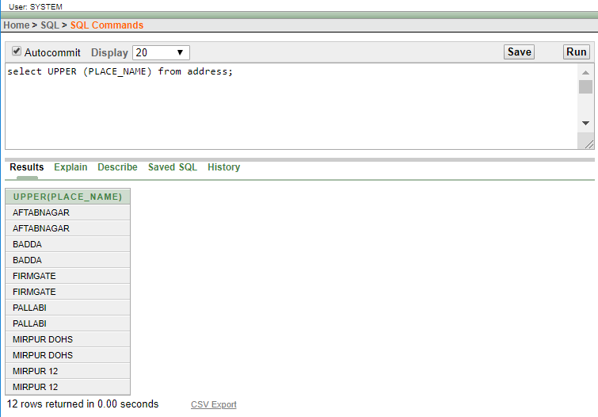

**GROUP FUNCTION:**

**1.Find the average salary of the beauticians .**

**Ans: SELECT AVG (B_SALARY) AS AVERAGE_BEAUTICIAN_SALARY FROM BEAUTICIAN;**

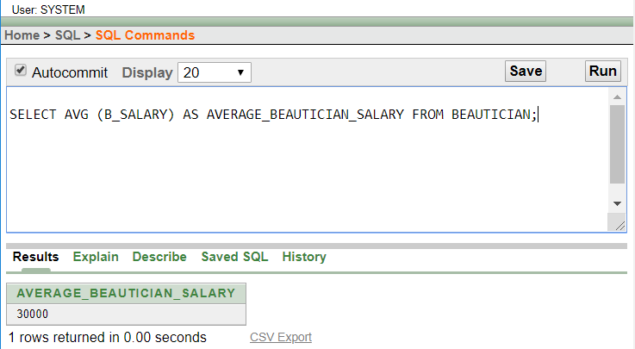

**2.Fnd maximum salary of a shop keeper.**

**Ans: SELECT MAX(SK_SALARY) AS MAX_SALARY FROM SHOP_KEEPER;**

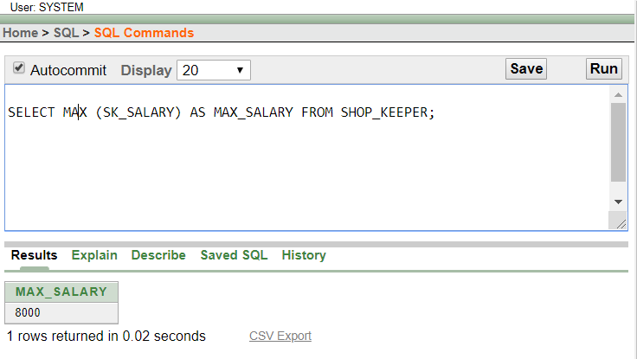

**SUB QEURY:**

**1.Find the name of managers who get more salary then m_id=161.**

**Ans: SELECT M_NAME FROM MANAGER WHERE M_SALARY > (SELECT M_SALARY FROM MANAGER WHERE M_ID=161);**

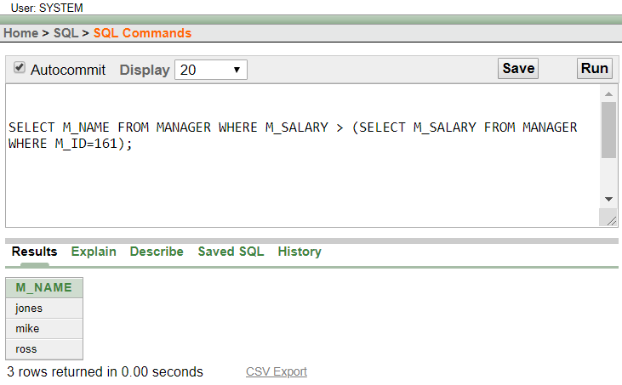

**2.Find the name of services which prices is more then s_id=666.**

**Ans. SELECT S_NAME FROM SERVICE WHERE S_PRICE > (SELECT S_PRICE FROM SERVICE WHERE S_ID=666);**

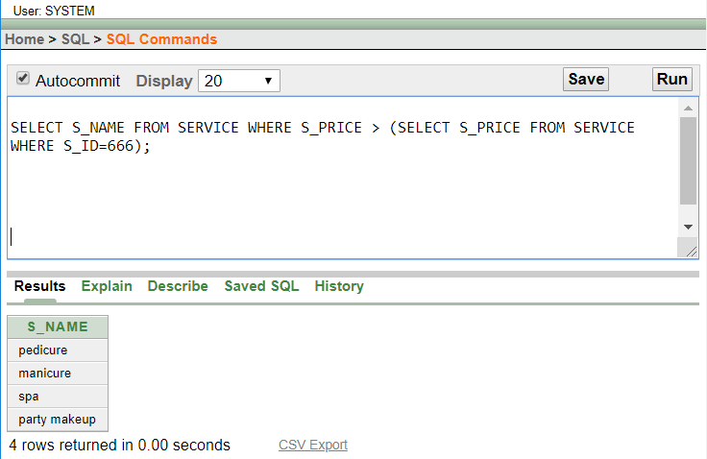

**JOINING :**

**1.Display the name of branches and its manager name.**

**Ans:** **SELECT MANAGER.M_NAME, BRANCH.BRANCH_NAME FROM MANAGER, BRANCH WHERE MANAGER.BRANCH_ID= BRANCH.BRANCH_ID;**

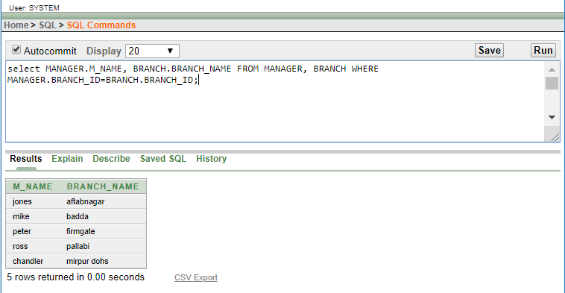

**2.Display the manager name and his beautician name.**

**Ans: SELECT MANAGER.M_NAME, BEAUTICIAN.B_NAME FROM MANAGER, BEAUTICIAN WHERE MANAGER.M_ID= BEAUTICIAN.M_ID;**

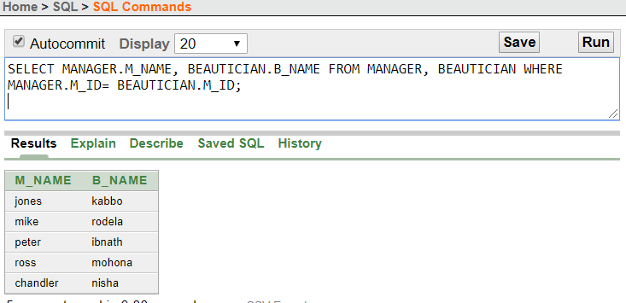

**CONCLUTION:**

**All of our group member worked hard to complete this project. As we had gone through the entire DBMS now we are really confident to create an accurate and giant DBMS for any kind of institute.**